Team CodeCrafters
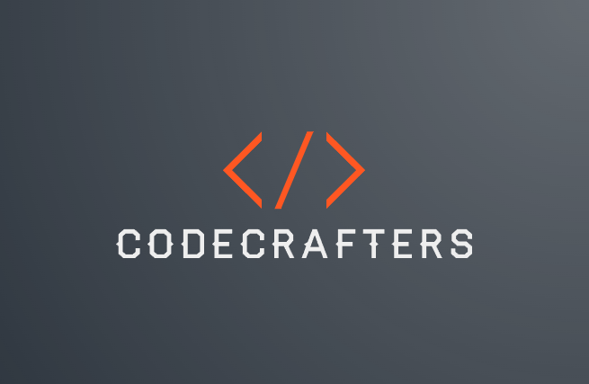
Name | Role | Grade
Veselin Boyanov | Full-stack developer | 10a
Panayot Andonov | Designer | 10g
Dimitar Dimitrakov | Scrum Leader | 10a
- Our Team

Application Description
Our project is a banking application built in C++ that allows users to create accounts, check balances, income and expenses securely. It focuses on implementing essential banking functions with an emphasis on data handling, security, and user-friendly interactions.

- Stages of Realization
1st week-brainstorming the ideas and focusing more in school.
2nd week-choosing the applications we will use during the realization of the program and setting up raylib.
3rd week-talking out the main problems, issue creating and working.
4th week-finishing and making last touches on the work

- Used Technologies
GitHub – for the project synchronization.
Git – to commit our changes.
C++ – for creating the app.
Power Point – for creating the presentation.
Word – for creating the documentation.
Teams – mainly for communication
Lua – for creating the builder

